Task 1 :

<!DOCTYPE html>

<html>

    <head>

        <title>Lab1</title>

    </head>

    <body text="FFB0B0">

        <img src="https://blogs.brighton.ac.uk/cnp14/files/2017/11/1-1ya0aup.jpg" alt="First Webpage" align="center">

        <h1 ><i>"A little bit about my self"</i></h1>

        <h2>My Good Name is Hafsa Irfan</h2>

        <h2 >My Roll no is 21F-9072</h2>

        <h3>I am a CS student and I'm excited about the opportunity to be a part of this university!</h3>

    </body>

</html>



Task 2:

<!DOCTYPE html>

<html>

    <head>

        <title>Lab1</title>

    </head>

    <body bgcolor="FFB0B0" text="WHITE">

       <strong>This text is strong</strong>

       <br>

       <big>This text is big</big>

       <br>

       <em>This text is emphasized</em>

       <BR>

       <i>This text is italic</i>

       <BR></BR>

       <code>This is computer output</code>

       <br>

       This is <sub>Subscript</sub>and<sup>superscript</sup>

       <br>

    </body>

</html>

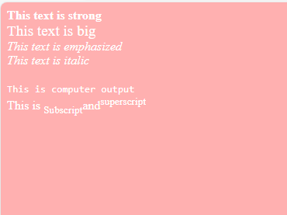

Task 3:

<!DOCTYPE html>

<html>

    <head>

        <title>Lab1</title>

    </head>

    <body bgcolor="FFB0B0" text="WHITE">

       <center> <img src="https://upload.wikimedia.org/wikipedia/en/e/e4/National_University_of_Computer_and_Emerging_Sciences_logo.png" alt="FAST LOGO" height="500" width="500"</center>

    </body>

</html>



Task 4;

<!DOCTYPE html>

<html>

    <head>

        <title>Lab1</title>

    </head>

    <body bgcolor="FFB0B0" text="WHITE">

       <a href="https://www.nu.edu.pk/"><center> <img src="https://upload.wikimedia.org/wikipedia/en/e/e4/National_University_of_Computer_and_Emerging_Sciences_logo.png" alt="FAST LOGO" height="500" width="500"</center></a>

    </body>

</html>

Task 5:

<!DOCTYPE html>

<html>

    <head>

        <title>Lab1</title>

    </head>

    <body bgcolor="FFB0B0" text="WHITE">

      <h1><b>HTML LISTS</b></h1>

      <H2>Unordered List</H2>

      <p>We have books on a variety of languages.</p>

      <BR>

        <UL>

            <li>Oracle</li>

            <li>Java</li>

            <li>HTML</li>

            <li>CSS</li>

        </UL>

        <H2>Ordered List</H2>

      <p>Follow these steps to install Java:</p>

      <ol><li>Download the software</li>

      <li>Extract to a folder</li>

      <li>Double click the executable to run</li></ol>

    </body>

</html>

